# FIT3179 DATA VISUALISATION

# Homework Assessment Week 10

## Create your own interactive visualisations in Vega-Lite

### Name: Jasmine See

### Student ID: 33155844

### Lab: Thursday 8:00am (Lab 13)

### Tutor Name: Chelsea Chong and Pooja Pancholi

* 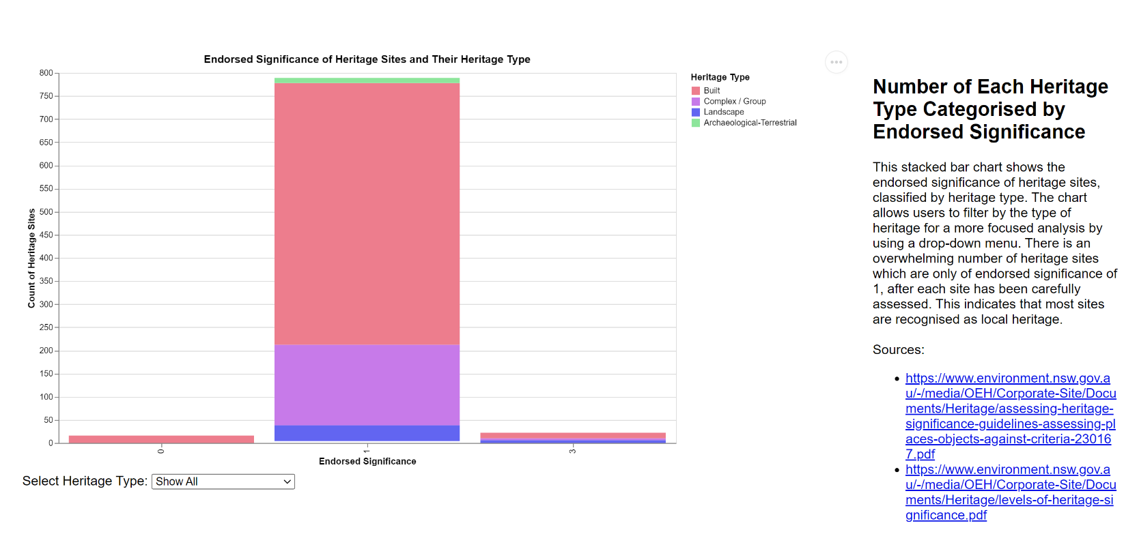**URL of HTML page:** [**https://thisstewisstu.github.io/fit3179/**](https://thisstewisstu.github.io/fit3179/)

**Domain:**

* Location (Address), School Names of NSW government schools, heritage item(s), heritage type, endorsed significance, suburb, local government area

**Visualised Dataset:**

* Location (Address) - nominal
* School Names of NSW government schools - nominal
* Heritage item(s) - nominal
* Heritage type - nominal
* Endorsed significance – categorical ordinal
* Suburb - nominal
* Local government area – nominal
* Sources:
  + Source of heritage sites and items in NSW government schools: <https://data.gov.au/dataset/ds-nsw-6dbeef7c-1abf-470a-9e5b-966f8cd4a2bb/details?q=schools>
  + Source of longitudes and latitudes: <https://data.nsw.gov.au/data/dataset/nsw-education-nsw-public-schools-master-dataset>

**Transformation(s):**

* The original csv file of heritage sites and items do not have longitudes and latitudes, so a python file was created to merge with another csv file containing longitudes and latitudes of government schools in New South Wales.
* Both CSV files had lots of fields that were not to be used, such as Heritage Group, Listing Number, Owner Code and Area Hectares, among others. As such, they were removed from the merged csv file that was used to create the map.

**Justification:**

* Since the dataset is location-based, with each school as its own point, using a chloropleth map would not make sense as they do not cover a large area. A proportional symbol map was chosen as it is useful for quickly comparing quantities across different areas and for visualizing spatial patterns or clusters. This type of map is effective for combining the different types of data – categorical nominal data such as endorsed significance and the heritage type can be combined. The size of the circle marks represents the level of endorsed significance, while the color represents the heritage type. This makes it easier to spot patterns and differences across the region immediately.
* A stacked bar chart is an effective choice for visualizing the heritage sites of government schools in New South Wales because it allows for comparative analysis of different heritage types and their endorsed significance. By displaying multiple categories in a compact format, it provides clarity on how each type contributes to the overall total. Additionally, it tells a clear narrative about the data, making it easier to spot trends and differences across the dataset, such as identifying commonly assigned endorsed significance levels.